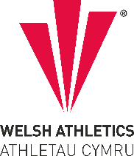

West Wales Regional Athletics Council

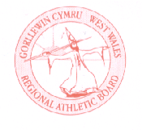
Minutes – West Wales Regional Athletics Council
Thursday 7th December 2023
Cwrt Herbert Sports Centre, Neath & Microsoft Teams Meeting

Present: Rob Campion Chairman
Nathan Jones Secretary
Les Cuthbert Treasurer
Andrew Jenkins Afan Nedd Tawe Schools Athletic Association
Lisa Campion Track & Field Committee Representative
Steve Hames Welfare Officer
Dic Evans FMR Committee Representative
Owain Schiavone FMR Committee Representative
Jennifer Boyce Pembrokeshire Harriers

Apologies: Kevin Tobin, Aled Jones-Davies, Neil Thomas, Mary Anthony, Nigel Jones
- Actions from Previous Meeting

- West Wales merchandise / club shop
Suppliers can do hoodies, t-shirts – black with little red as colour, early discussions ongoing. West Wales orders for committee members, sizes to be sent to Rob.

- Discussion
- Review of West Wales Cross Country Championships & Welsh Inter Regional Championships
Held at Pembrey Country Park on Saturday 14th October at the Gwent League 1. Selection race for the Welsh Inter Regional Championships at Newtown on Saturday 18th November. Agreed that top 13 would be selected plus another 2 in each age group. Good day for West Wales, finishing second at Newtown, winning a number of individual and team medals. Medals to be given to athletes who missed their presentations. Thanks to all those who made the long journey to mid-Wales and to Rob for all the administration work.

- UK Inter Counties Championships
Event moved to Wollaston Park in Nottingham (not Loughborough) on Saturday 9th March. Teams to be selected and entries by end of January – top 8 from inter regionals for U13 & U15 as they were well represented, top 6 U17’s plus two, all U20’s, top 9 seniors to see what interest is shown.

- Welsh Junior League – West Wales Review
Option for Neath to host the first fixture in April before the track is re-laid.

AGREED: no changes to be made to the current format (7 x clubs making up the West Wales division with opportunity for athletes to take part in all disciplines, no reduced programme).

Provisionally agreed to run steeplechase if time allows for older athletes looking for a time for a particular event. Will need to ensure that it doesn’t become an open meeting and attract large numbers.

- Welsh Inter-Regional Championships – Track Meeting 1 Feedback
There was a further meeting set up in October to discuss the future and format of the Welsh Inter Regional Track & Field Championships, which RB, SH & NJ attended. Date preferred is in June.

Proposed timetable and rotation of events created by Joyce has been circulated with the minutes. The timetable will need to be reduced when entry number is known as the proposed timetable is currently over 6 hours with no break, combining some disciplines such as 400m Hurdles, relays and u20/senior events.

- West Wales Indoor Championships – January 2024
Dates confirmed around the West Glamorgan Cross Country League and Cardiff Met Non Thomas New Year Open.
Day 1 – 60m, 60m Hurdles, Shot – Saturday 13th January
Day 2 – Long Jump, Triple Jump, High Jump, Pole Vault – Saturday 20th January
Entries agreed as £5 per event.

200m, 300m, 400m, 800m, 1500m championships for U13 – U17: to be incorporated into the Welsh Athletics Junior Indoor Open Meetings at NIAC, Cardiff on 3rd December and 7th January as in previous years. Entries for Swansea are open and closes on the Monday before.

- Gerry Batty Award
Nominations been open to clubs for the Gerry Batty Memorial Award – U17/U20 Junior Athlete of the Year. Closing date for nominations was on 1st December. There was just the one nomination for Michael Jenkins who was awarded the trophy.

Moving forward from 2024, the committee will decide on the recipient due to low number of nominations / interest received from clubs.

- Affiliated Clubs
Welsh Athletics have confirmed there are two new affiliated clubs in West Wales – Swansea Vale Tri Club and Ferry Flatliners.

- Red Kite Challenge
Entries for the Red Kite Challenge are open, correct entry link is on the website/official event page. Selection race for U18 international event. U14, U16, U18 for junior races agreed instead of U13, U15, U18 previously.
West Wales race to remain at five-year gap for senior age groups.

- Information - Reports
- General Council
The last meeting was held on Wednesday 22nd November. The minutes from the last meeting has been circulated by email.

- Track and Field Committee
Meeting cancelled on Wednesday 6th December due to availability. West Wales outdoor athletics championships – Sunday 12th May likely date.

- Officials Secretary
No update to report.

- Road Running/Cross Country Committee
The last meeting was held on Wednesday 15th November. The minutes from that meeting has been circulated by email.
Championship Races and 10k Series
Expressions of interest to be advertised on WA web site to host Welsh 5 and 10k Championships and also 10k Series
Fixtures
Welsh Schools Championships confirmed as 28th Feb 2024 venue Brecon
Performance
Lists of supported athletes to be published in next few days (now done)
European Clubs Cross Country (28th Feb 2024)
Due to clash with English and Scottish National X/C Championships invite had been declined by both countries and so Welsh Teams offered the opportunity of attending
As winners of last year’s Welsh Championships Swansea Harriers Men and Les Croupiers `= Women to be offered the opportunity to attend

- FMR Committee
Meeting this week. How many international races will Welsh Athletics be supporting next year – currently 3 and trying to remove one. Upcoming dates attached with the minutes.

- Welfare Officer
No update to report.
- Financial Report (correct on Wednesday 6th December)

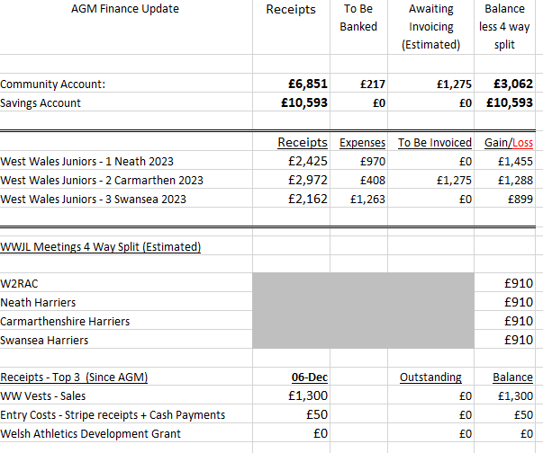
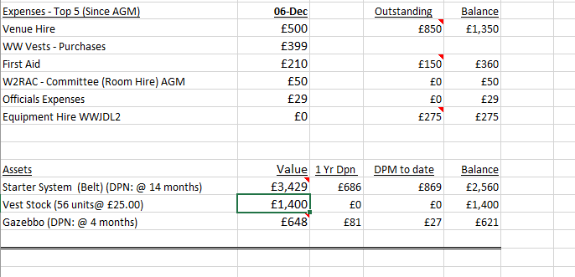

Discussion/Agreement from LC:
- Proposed that any outstanding invoices received from a hosting Club after 90 days will not be re-imbursed. Responsibility for payment will then become that of the host Club for the meeting, unless prior agreement reached with W2RAC. Agreed

- Proposal that re-imbursement of dividend from West Wales Junior League (WWJL) meetings held at Neath and Swansea in 2023 be paid directly to both Clubs within next 7 days. Agreed

- Proposed that with the agreement of the Louise Arthur Clubs (LAL) funds held in Nat West bank account be transferred into W2RAC Bank account for equal re-distribution to those Clubs involved. I will contact each Clubs to gauge interest. Not all Clubs were from West Wales. Agreed, four clubs outside the region to receive share, five West Wales clubs to be contacted around what to do with the money

- AOB
Endurance training days – RDP day has been removed by Welsh Athletics. Proposal to run endurance training days at Pembrey Country Park for club members in the region. Agreed that region will support.

- Date of Next Meeting Friday 9th February at 6:30pm (In person & virtually online)

